Assembly Programming with the MSP430
Embedded Systems Design Final Report

Joe Strinka
Electrical Engineering
Rochester Institute of Technology
Rochester, NY, United States
Jrs5885@rit.edu

Summary of Program
The general requirements for this lab exercise were to create an assembly code using the MSP430 that takes an input from the user in the form of Capacitive Touch LEDs in order to sample a 1V peak to peak sine wave from an arbitrary waveform generator and then simultaneously display the samples using a conversion and the built in LEDs, as well as output the number of LEDs that should be lit to the serial communication terminal using UART communication. The code is broken up into functions, which are called by the main loop or other functions being used as the program progresses. Figure 1 displays a High Level flow chart of the program, which includes detecting which LEDs are pressed, as well as acquiring data, converting the data to a corresponding number of LEDs, and then Displaying the number of LEDs to be lit both using hardware (the LEDs on the MSP430 capacitive touch sensor) and in software (the terminal). In the first step of the program, the program simply waits for the center sensor to be pressed, after the center LED is pressed, the program will then wait for the Up or Down sensor to be pressed. If the Up sensor is pressed, then the sample will be collected at 100Hz. Alternatively, if the down sensor is pressed, the sample will be collected at 200Hz. After either the Up or Down LED has been pressed, the program waits for the Left or Right sensor to be pressed. If the left sensor is hit, then the display function will display one value every second using the LEDs in the capacitive touch sensor. If the right sensor is hit, then the display function will display for two seconds instead. After the sensor routine has been run and the values for sampling frequency and display duration have been set, then the code moves on to the data acquisition portion. The acquisition code utilizes an analog to digital converter that is triggered by a timer interrupt in order to sample data at the rate specified by the sensor portion of the program. Since a sine wave is input, one would expect a sine wave as the output. The two sampling frequencies are 100 and 200Hz, which indicates that for the 200Hz code, twice the amount of sine waves would be expected to have gone through the program and been captured. One way to check the code functionality is to plot in Excel the values that are being acquired and graph them in a scatter plot with a moving average of 2.After the data has been acquired, it is then converted to the required number of LEDs to be turned on in a leading 1, non-linear scale. The data must be shifted a total of 6 times before the conversion starts because the registers in the MSP430 are 16 bits, not the 10 bits of the number that the analog to digital converter outputs. Then during the conversion, the number is shifted until the carry bit is a one and then depending on the number of times it was shifted a value for number of LEDs is stored. In the display function the number of LEDs is compared in order to decide whether to just light up the LEDs or whether multiplexing is needed. Multiplexing is required if more than 4 LEDs are to be lit up because the MSP430’s capacitive touch sensor LEDs use an inverted style to light up the left and right side, meaning the technically cannot both be lit up at the same time. However, by alternating very quickly, the illusion of both sides being lit can be created. After the value of the number of LEDs is output to the LEDs on the capacitive touch sensor, the value is also output to the serial communication terminal. Once all of the values have been displayed and output, the code repeats and waits for the center sensor to be pressed again. Fig 1 describes the main loop of the code enumerating the various functions that are called.
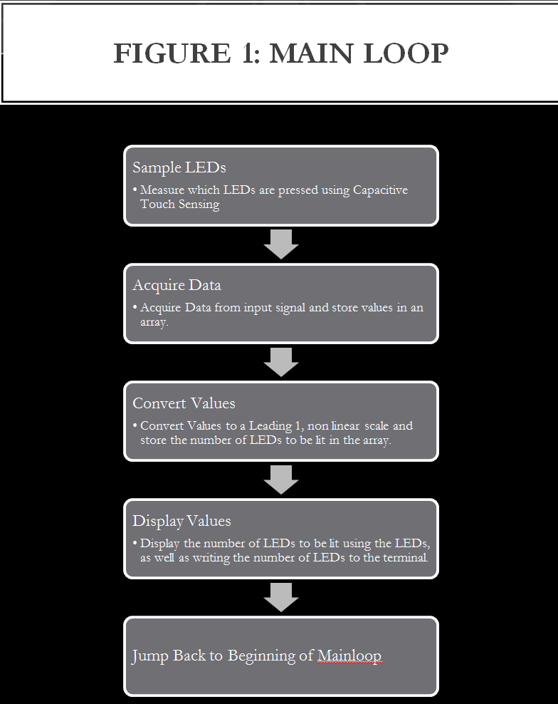
The main loop is split up into four different subsections; the most complex subsections are the Acquire Data and Display Values functions. Fig. 2 enumerates the three different sections of the Sample LEDs subsection. 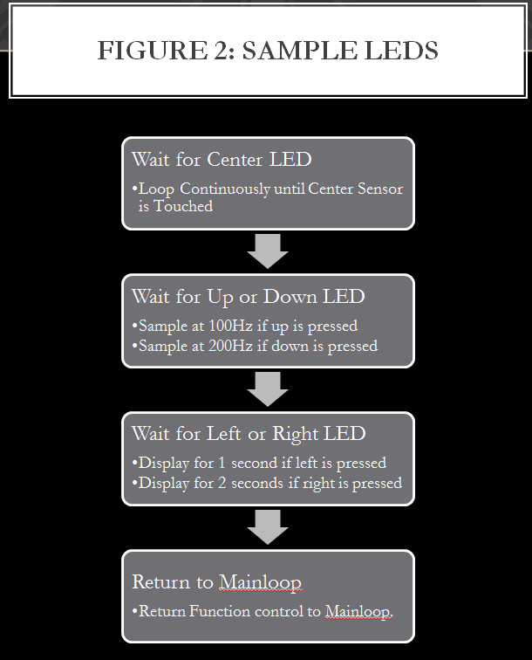
Since there were three steps to the sample LEDs section, it was logical to break the subsection into three different parts. The first part is to wait for the center capacitive touch sensor to be touched to signal that the user would like to start the program. The other two steps set a variable depending on which option is selected. Fig 3 lays out the general flow of the Acquire Data subfunction.
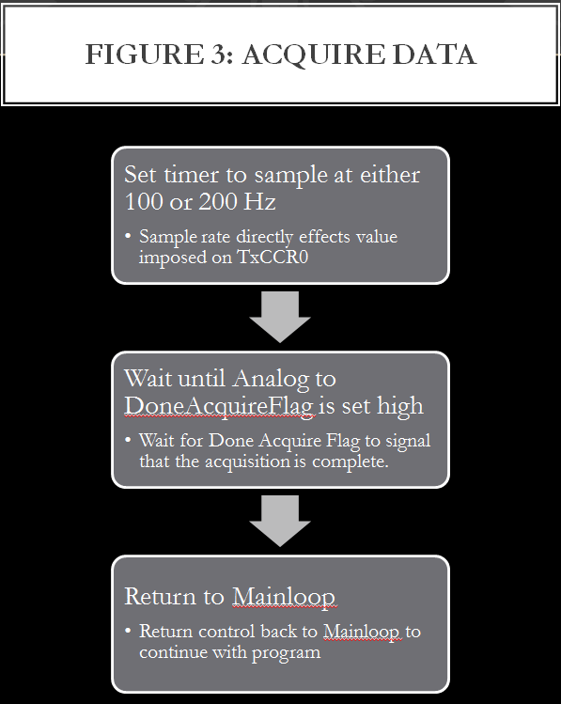
The main function of Acquire Data is just a place holder and stays in an infinite loop until the DoneAcquireFlag is set to high. The process of setting the DoneAcquireFlag to high is explained in detail in Figure 4.
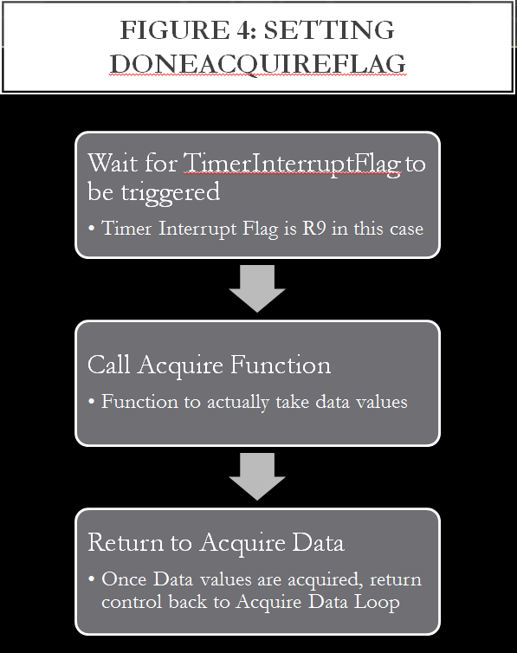
The DoneAcquireFlag signals that all values have been acquired and will only be set at the end of the Acquire function just before returning. Theoretically, the Acquire Function could be inserted into this loop but to keep the code reusable and modular it was separated into its own loop. Fig 5 walks through the Acquire Function.
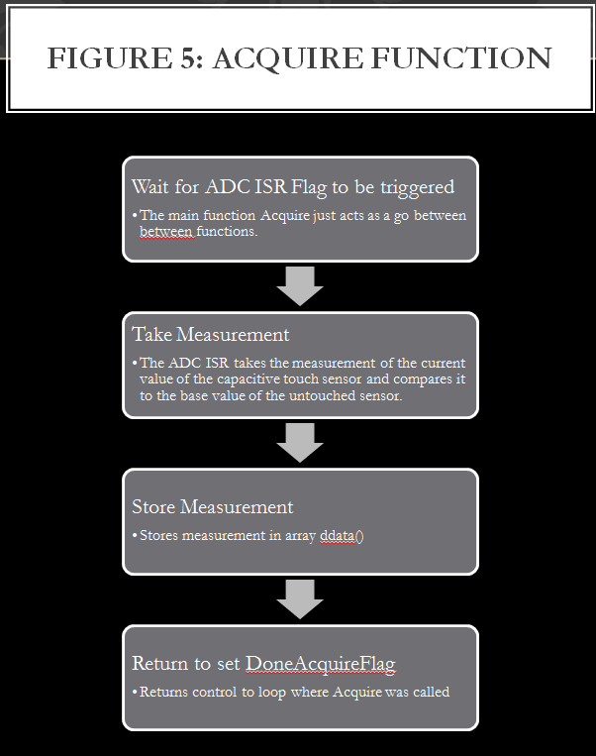
The Acquire Function is one of the most complex functions in the lab experiment. The main function of the Acquire Function is to read a value, and then use the analog to digital converter (ADC) in order to convert the input voltage into a ten bit binary number. The Acquire Function then stores that value into an array to be accessed by the conversion function later. Fig 6 describes the workings of the conversion function.
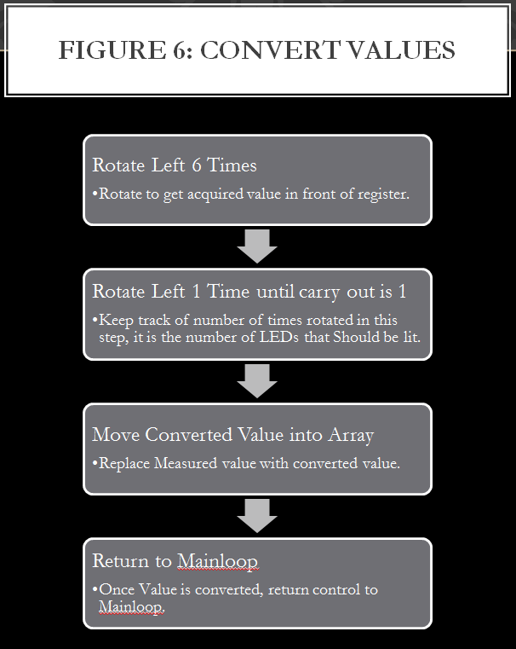
Since a register is used to store the value of the array before manipulation, and the ADC stored a 10 bit value into a 16 bit register, the original value must be shifted left six times in order to set the ADC value at the front of the register. Once the value is in the correct spot another register is used to count how many times the value is shifted left before the carry out is a 1. Eight minus the value of this second register is the number of LEDs that must be lit up according to the “Leading 1, non-linear scale” outlined in the lab handout. In order to save memory, the number of LEDs to light up is then overwritten onto the original ADC value taken from the input. The last step in the code is to display the LEDs and print the same number to the terminal. Fig 7 outlines the process used in the Display Values subsection.
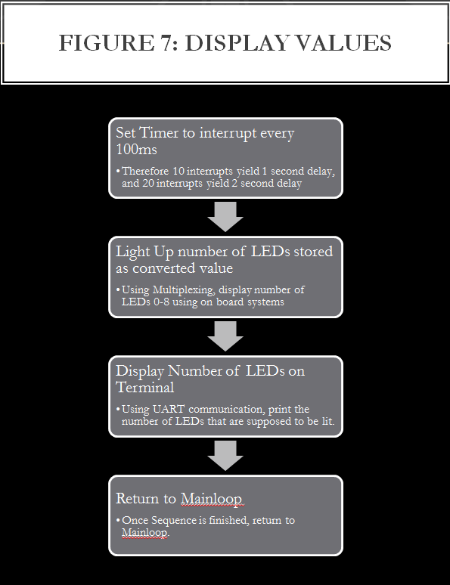
Using the LEDs on board the capacitive touch sensor, the number of LEDs to be lit up was determined by the conversion function. Every time the number of LEDs lit up changes, a new value should be printed to the terminal.

Design Choices and Considerations
Although in this exercise there was an option to use assembly, c, or a combination of the two, only assembly code was used. The main reason for only using assembly code was that throughout the course, most of the code examples that were given in previous labs were done in assembly and not c. There was also theoretically a lecture on how to mix the two, but it was easier and made more sense to complete this exercise in only assembly code. If completed for a real world application, it would have been more efficient to learn to mix assembly and c and implement higher levels of the program in c while keeping the inner workings of the code in assembly. Another thing that could be changed to improve readability would be to split up different parts of the code into different files. Since there was no previous lab that taught how to split up the code, the time was not taken to learn how to split up the code into different files properly and any attempt to split the code into more readable pieces failed. One consequence of the massive code was that occasionally, when adding a portion, a different part of the code would get separated from the code that it works with. For example, the measure setup function is located at the bottom of the code as opposed to near the measured value code which is a considerably 400 lines above. The misplacement of functions does not hinder the functionality of the code, but it does make it considerably more difficult to read and follow. Another design consideration that could be used to improve readability would be to define and use variables instead of registers for the inner workings of the code. In this code, registers are used instead of variables which could result in loss of data by overwriting a register that is not finished being used by one section of the code, in order to prepare it to be used in the next section of the code. A final consideration that could be changed to implement a more readable code is changing the header names to represent what the code does. Some of the current header names were written after working on this code for more than 8 hours straight and are understandably poorly or goofily named. One consideration that made this code longer than it necessarily had to be was to write the functions to light the LEDs exhaustively as opposed to using a compare statement and loop structure. Using the loop structure would have taken about 100 lines of code, and condensed it to less than 10 lines.

Solution Method
The general solution plan that was followed in this lab was to write out pseudocode for all main functions at the beginning, and then slowly write and debug one function at a time, which resulted in a slow process that was reasonably accurate at the end of the first attempt. Since all functions were debugged once they were written, the program errors at the end of the first attempt had to do with how the main functions communicated with each other as opposed to the code that was in the main functions. For example, one of the main problems encountered with communicating between systems was when my display function was not communicating with the values found in the converted values. The problem was reasonably easy to fix because most of the code was functioning, there were just small nuances that needed to be rectified. If the lab were to be restarted, the same methods should be used in order to minimize the time debugging once all the code is written. It is also beneficial because all the code is modular and can be reused in different applications.

Conclusion
The majority of this lab was completed in previous labs, but there were some caveats that were difficult to implement given the way that the specific code was implemented. The only thing that does not work on this lab is that instead of printing to the terminal once per cycle, the code prints to the terminal twice for every value. Given infinite amounts of time, this could be rectified by taking apart the entire display function and putting together a non loop based structure. Unfortunately there are not infinite amounts of time.

